1. To get the database code to work on your computer
   1. Install "System.Data.SQLite" extension in Visual Studio
      1. 1. Make sure you are in the solution (i.e: test_gui.sln). You go to Tools > NuGet Package Manager > Manage NuGet Packages for Solution >Browse > Type in "System.Data.SQLite" and install the software.
2. To interact with SQLite database with a user interface (GUI) install DB Browser
3. Importing SQL files to populate the database with sample data:
   1. Open DB Browser
   2. Select “Open Database”

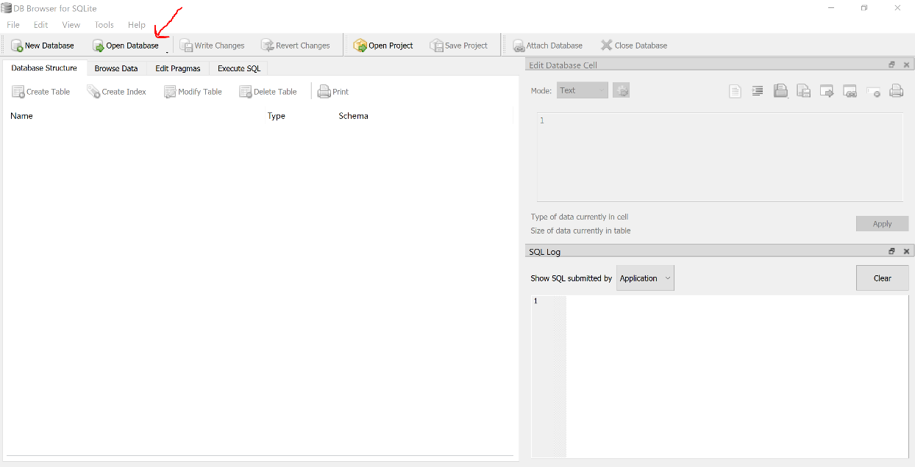

* 1. Navigate to where the database is stored in File Explorer
  2. Select the database desired and select “Open”
  3. 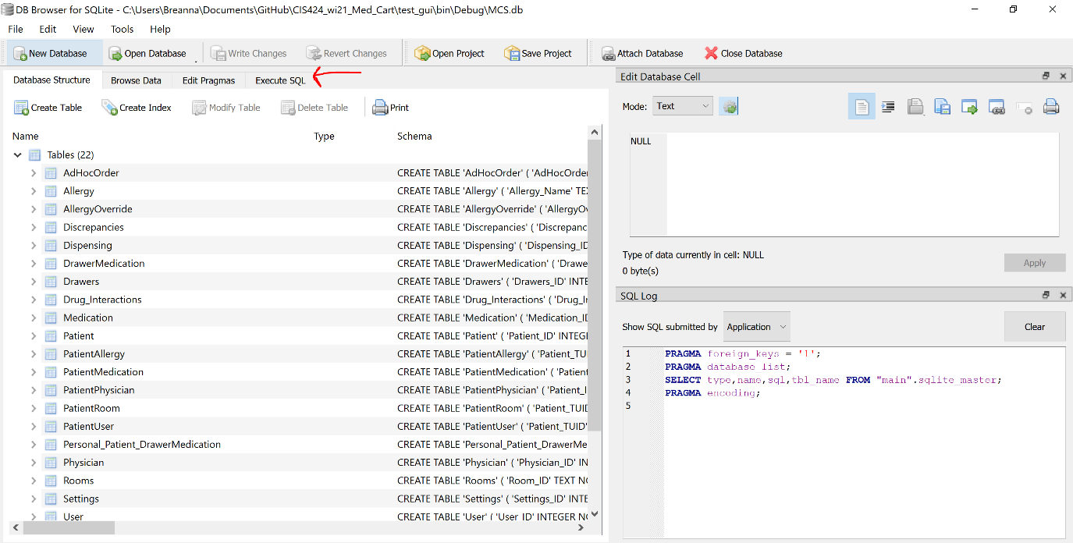Select “Execute SQL”
  4. Select the “Open SQL file(s)” button 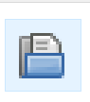
  5. Navigate to the folder housing the desired imported SQL file
     1. If you have the GitHub repo stored on your device, the correct SQL files are stored at this location
  6. Select all the SQL files and select “Open”
     1. Five files will be opened
        1. Allergy
        2. Patient
        3. Physician
        4. Rooms
        5. User
     2. Once opened, five tabs will show on DB Browser
  7. Select the tab of the data you want to import in the following order and select the “Execute all/selected SQL button 
     1. Physician
     2. Rooms
     3. Patient
     4. Allergy
     5. User
  8. Now the database has sample data in the five tables listed above.